Chess Battle
Test Document
Version <1.0>

Prepared by:

XYZ

17/10/2016

Test Cases for Chess Battle
The following test cases are performed to uncover errors and to check the proper functioning of the software. It also checks whether it is able to follow all the rules of the game and the can pursue the game according to the desire of the player, if the rules permit (otherwise show an error message).

Test Case 1:
Input: To compile the program without the errors.

Status: No compilation error shown

Output: The program is compiled properly without any errors if any errors are occurred it will be displayed below the compilation input, so in this test case there are no errors so the compilation was successful and was preceded to the next step.

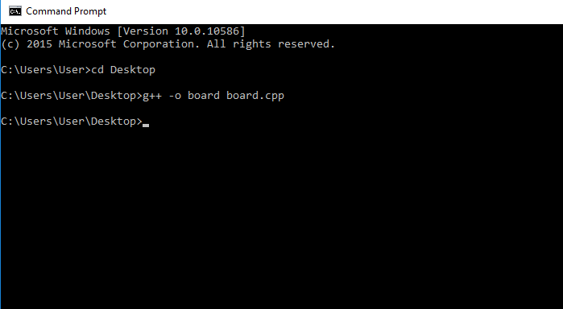
Figure 1: command prompt of tdm gcc(compile command)

Test Case 2:
Input: To execute the program by giving the command.

Status: Board displayed

Output: After entering the code for execution of the program the command prompt will automatically pop up an interface which is as shown below, if there are any run time errors in the program the board will not appear.

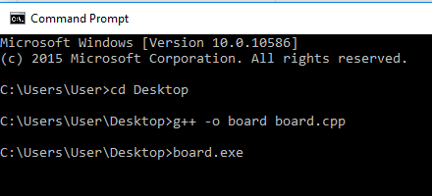
Figure 2: Command prompt of tdm gcc(run command)

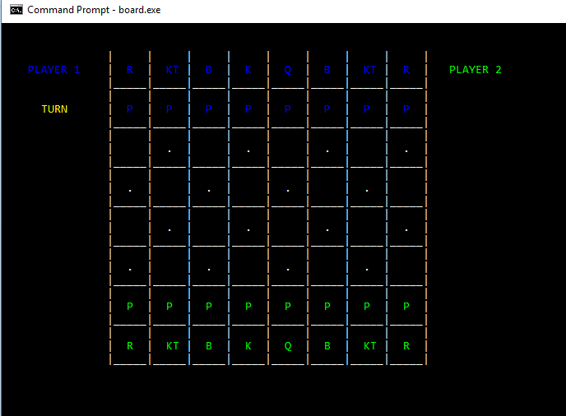
Figure 3: User interface of the game

Test Case 3:
Input: Check whether all the pieces of the both sides are available or not and also check whether they are properly organized or not.

Status: Performed

Output: All the pieces are available and fairly organized for both sides which are satisfying the basic rules of the game is shown below.

Figure 4: interface showing arrangement of all pieces

Test Case 4:
Input: Check whether the program is showing whose turn is next to play and also the invalidity of selection.

Status: Performed

Output: The “Turn” flag is properly showing whose turn is next and shifts to that player side. If the player tries to play when it is not his turn then a message “INVALID SELECTION” is displayed.

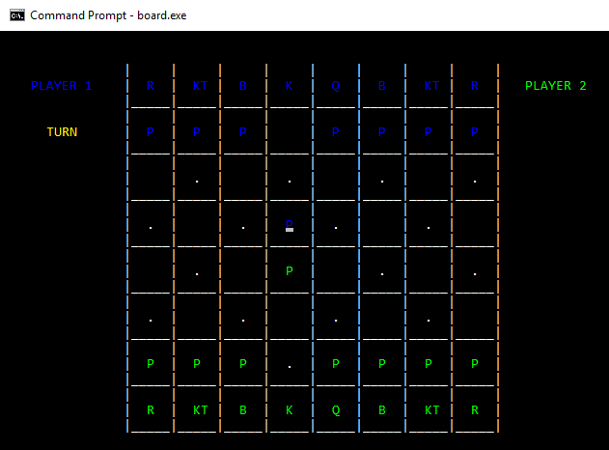
Figure 5: GUI showing the turn of player 1

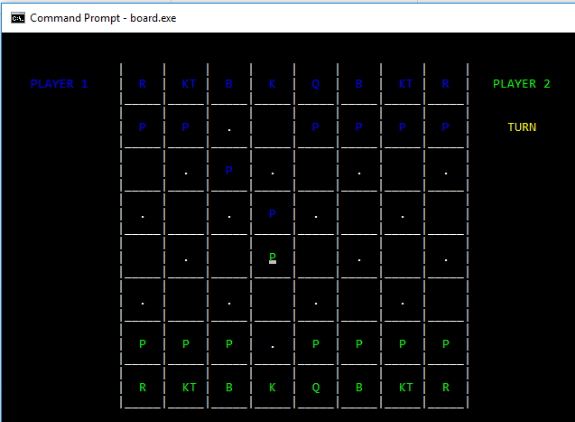
Figure 6: GUI showing the turn of player 2

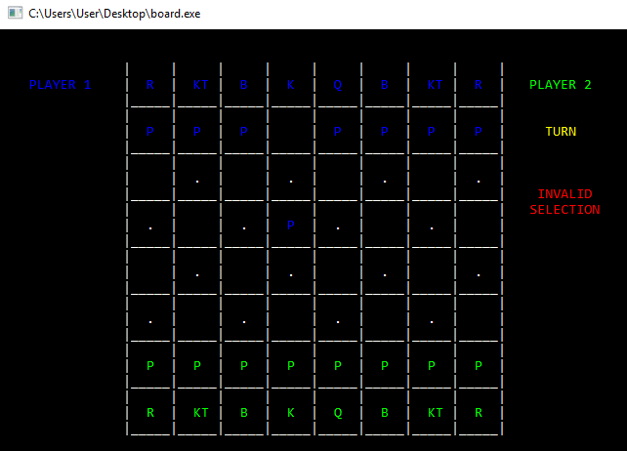
Figure 7: Screenshot showing the invalid selection of piece

For playing the game the most important thing is to check the moves of all the pieces:

- Pawns: Pawns can only move forward. On their first move, they can move one or two squares. Afterwards, they can move only one square at a time. They can capture an enemy piece by moving one square forward diagonally.

- Bishops: Bishops can move any number of squares diagonally.

- Knights: Knights can move only in an L-shape, one square up and two over, or two squares over and one down, or any such combination of one-two or two-one movements in any direction.

- Rooks: Rooks can move any number of squares, up and down and side to side.

- Queens: Queens can move any number of squares along ranks, files and diagonals.

- Kings: Kings can move one square at a time in any direction.

The movement of all the pieces on the board should be according to rules specified above and if any illegal move is made by the player then that move should be restricted and a particular message should be displayed to inform the player.

The tests that checks the movement of the pieces are as follows:

Test Case 5:
Input: checking the move of the pawn.

Status: Performed

Output: It is satisfying the rules of the game if any other move that is not a valid move of pawn is performed a message “INVALID MOVE” will be displayed.

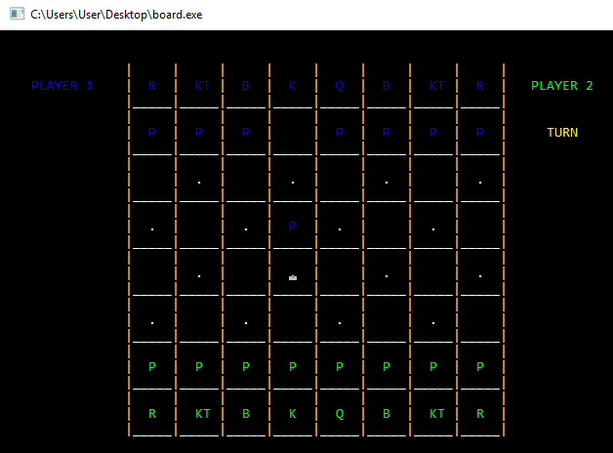
Figure 8: Screenshot showing the movement of pawn
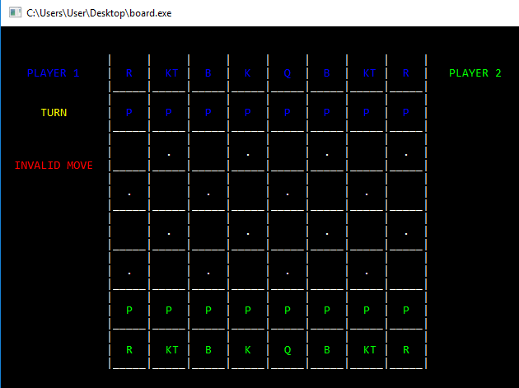
Figure 9: Screenshot showing illegal move is performed

Test Case 6:
Input: Checking the move of the knight.

Status: Performed

Output: It is satisfying the rules of the game if any other move that is not a valid move of Knight is performed a message “INVALID MOVE” will be displayed.

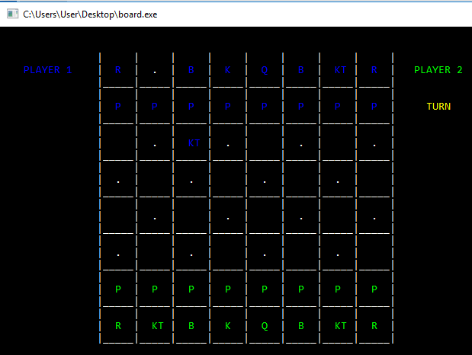
Figure 10: Screenshot showing movement of knight
Figure 11: Screenshot showing illegal move is performed

Test Case 7:
Input: checking the move of the Rook.

Status: Performed

Output: It is satisfying the rules of the game if any other move that is not a valid move of Rook is performed a message “INVALID MOVE” will be displayed.
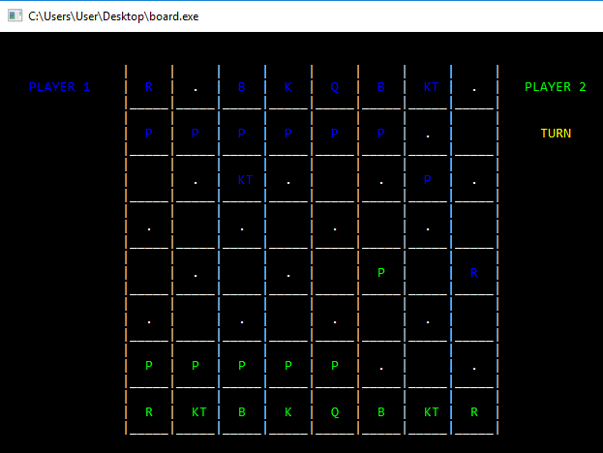
Figure 12: Screenshot showing movement of Rook

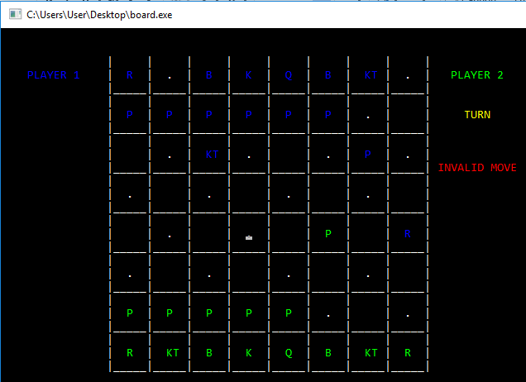
Figure 13: Screenshot showing illegal move is performed

Test Case 8:
Input: checking the move of the Bishop.

Status: Performed

Output: It is satisfying the rules of the game if any other move that is not a valid move of Bishop is performed a message “INVALID MOVE” will be displayed.
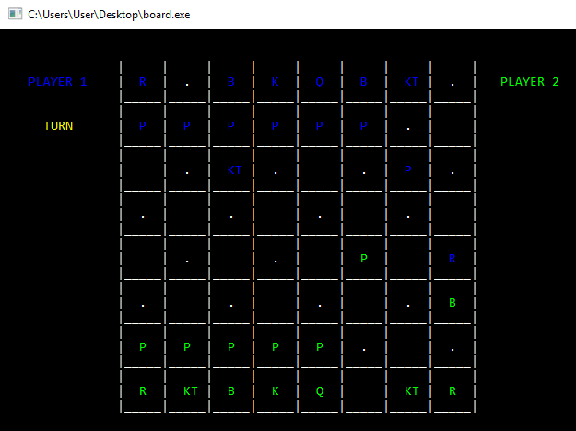
Figure 14: Screenshot showing the movement of Bishop
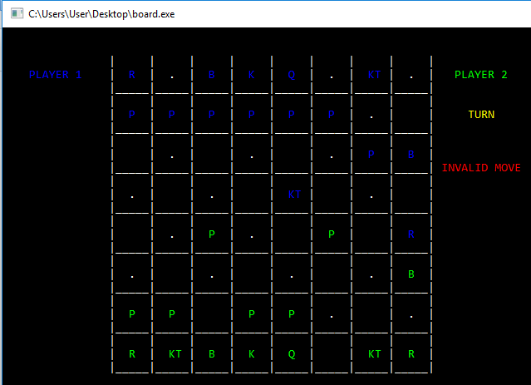
Figure 15: Screenshot showing illegal move is performed

Test Case 9:
Input: checking the move of the Queen.

Status: Performed

Output: It is satisfying the rules of the game if any other move that is not a valid move of Queen is performed a message “INVALID MOVE” will be displayed.
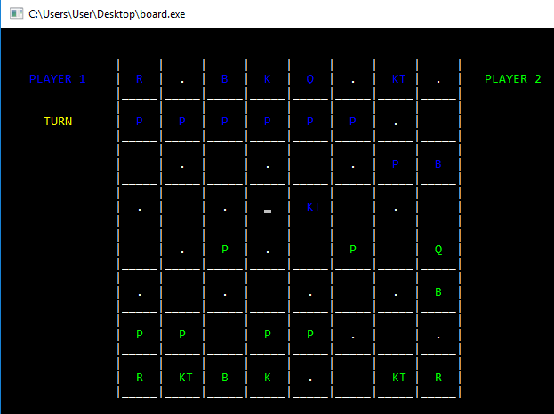
Figure 16: Screenshot showing the movement of Queen
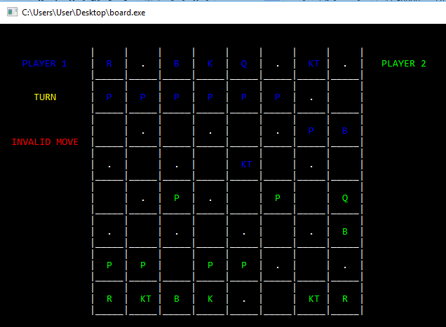
Figure 17: Screenshot showing that illegal move is performed

Test Case 10:
Input: checking the move of the King.

Status: Performed

Output: It is satisfying the rules of the game if any other move that is not a valid move of King is performed a message “INVALID MOVE” will be displayed.
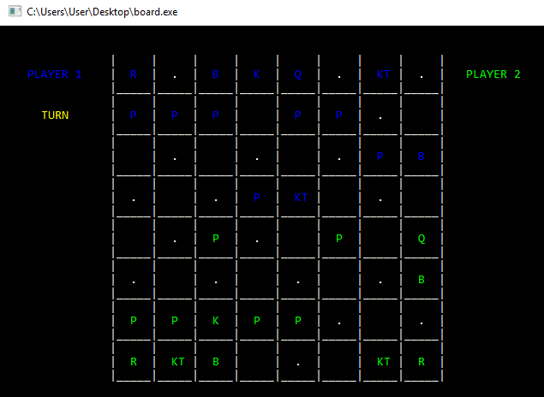
Figure 18: Screenshot showing the movement of King
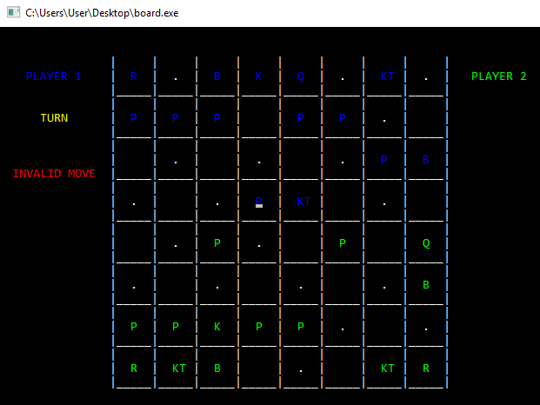
Figure 19: Screenshot showing that inavlid move is performed

Test Case 11:
Input: checking the move of the kills performed each and every piece.

Status: Performed

Output: It is satisfying the rules of the game. If a player wants to kill another player’s piece following all the rules then the piece will be substituted by other hence it is able to perform killing.
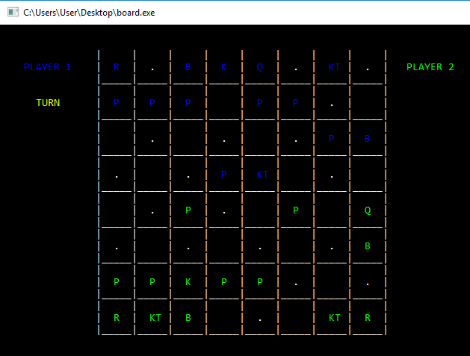
Figure 20: Screenshot showing the initial position
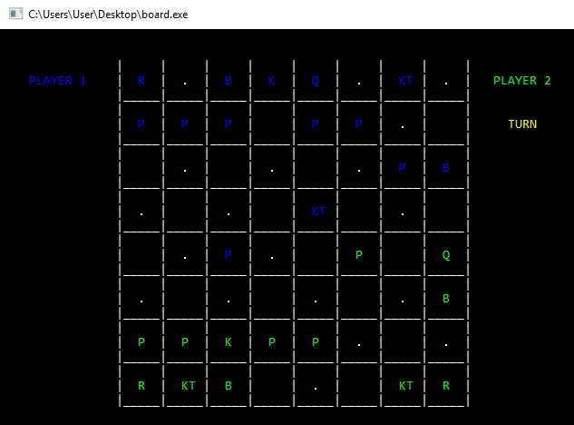
Figure 21: Screenshot showing the position of pawn after killing

